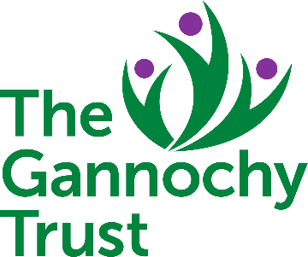
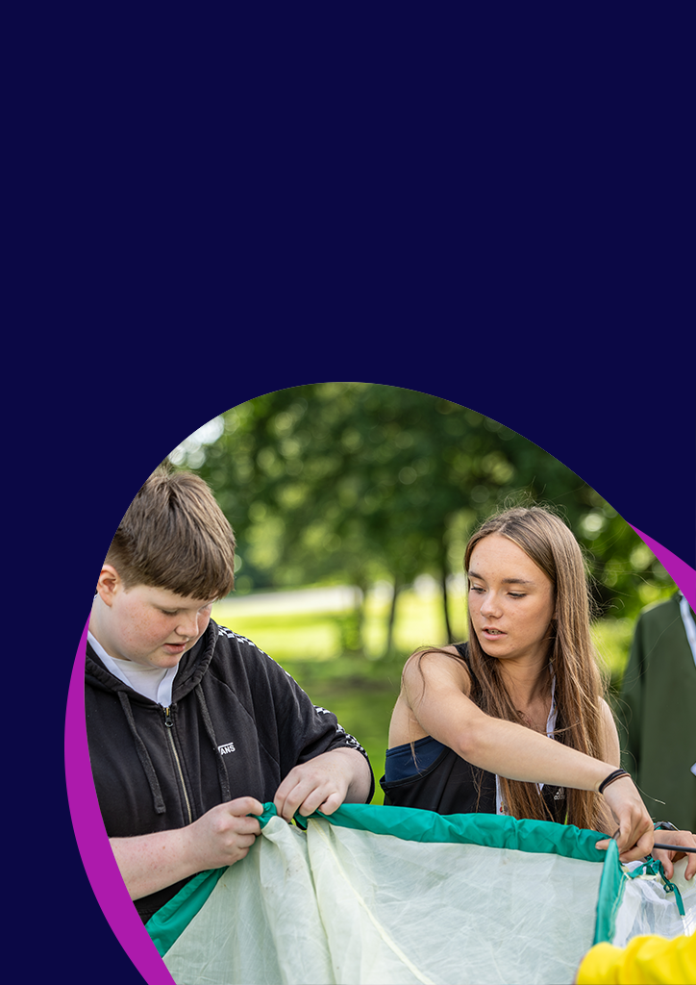


Youth Scotland Rural Action Fund

Supporting community-based youth work

Guidance for applicant youth groups

Guidance for applicants

What is the Rural Action Fund?
The Youth Scotland Rural Action Fund is a micro-grant fund supported by The Gannochy Trust. This fund was created in response to the challenges which rural youth groups are facing in funding the delivery of community-based universal youth work. It will make small awards to enable youth groups operating in rural communities to provide more and/or better youth work opportunities for young people. The priority for this fund is to support/enable typical youth work activities that directly benefit young people in rural youth groups.

The minimum amount of funding is £100 and maximum amount per award is £750

Who can apply?
Youth Scotland member youth groups which:

- Are based in Scotland
- Operate in rural communities with a maximum of 2 Full Time Equivalent (FTE) staff members (If you have more than 2 FTE staff members for fixed periods e.g. during holidays, please contact us as you may still be eligible for funding)
- Are universal access for all young people
- Work with young people aged between 5 to 25 years old
- Want to try new things, enhance existing provision or increase your capacity to deliver a specific project or programme
- Plan to spend the grant by end August 2026.
- Can provide evidence of an annual turnover less than £200,000
- Are applying for between £100 and £750. No match funding is required

When are the application deadlines?
Applications should be received by:

- Thursday 12 February 2026

What happens after I apply?
Once we have received your application, we will review this to make sure all the information we need is included. Applications will be considered by a grants panel, and we aim to let you know whether you have been successful the week of 23 February
2026. All funds to be spent by end August 2026.

The priority for this fund is to support/enable typical youth work activities that directly benefit young people in rural youth groups.
What will we fund? | What won’t we fund?
- Equipment and programme materials  - Programmes of activities  - One-off events  - Venue hire  - Travel costs to an activity  - Promotional material  - Specialist tutor/ facilitator costs e.g. art tutor, sports coach, dance tutor, filmmaker  - Sessional youth work staff costs.  - Membership fees and essential insurance costs  - Building repairs and maintenance work e.g. boiler repair (where you own or have a long-term lease on the property)  - Hall lets  - Training costs for volunteers/young leaders  - IT equipment to enable digital engagement of young people and delivery of online activities  - Video-calling licences | - Youth groups which are not currently members of Youth Scotland.  - Salary costs of existing staff. But we will fund additional sessional youth work costs required for specific programme or event or costs for specialist tutors.  - Youth groups with an annual turnover of £200,000+ per year.  - Uniformed youth groups.  - Building upgrades e.g. new toilet  - Activities which take place outside of Scotland.  - Projects and activities which incorporate the promotion of political or religious beliefs.  - If you are currently in receipt of funding directly from The Gannochy Trust, please contact us before applying.

Supporting youth work in rural communities
We know that funding is only one of the factors that contribute towards high quality youth work opportunities for young people. At Youth Scotland we offer support and training to youth workers and youth groups to help improve the quality of youth work which young people are experiencing. Although not a requirement of receiving funding we would expect that youth groups funded through the Youth Scotland Rural Action Fund will take part in our training programme. This is intended to help build the capacity of your youth group over the longer term. Further details of Youth Scotland’s training can be found at www.youthscotland.org.uk/training-events or please contact us by calling: 0131 554 2561 or emailing training@youthscotland.org.uk to discuss how we can support you.

Supporting youth work in these challenging times
We know that we are all living in a period of challenging times. Youth Scotland has supported community-based youth work for over 90 years, and we stand ready to support youth workers in communities across Scotland to meet this issue head on. Our aim is to be at the heart of sustaining youth groups to support young people in meaningful ways, turning this difficult time into an opportunity to transform the way we operate.

Please stay in touch with us throughout this period so we can share your stories of endeavour and success in helping young people and your communities. The questions we have asked in the application form and the feedback you give us will help us communicate to funders and other decision-makers about the challenges you are facing. If things change due to factors beyond your control just let us know and we can discuss how you may be able to use the funds in another way that benefits young people in your youth group and community.

Questions to expect on the Application Form
So you know what information to have to hand, these are the questions we will ask you in on the online application form. You might want to prepare them in advance and have them to hand/copy and paste. Each question is either a simple yes/no answer, tick boxes or an open text box (as indicated below).
- What are your Youth Group details? (Name, Address, Contact Information, Income, etc.) (text box)
- Your Youth Scotland membership number beginning with 350.. If you don’t know this, call or email us and we can tell you your number.
- What services/activities do you offer to young people in your community? (text box)
- What are the proposed activities/events for which you are applying for funding? (text box)
- Is this activity new? (yes/no)
- What is the Start and End date of the project? (text box: ensuring that your activities complete by end August 2026).
- How many young people will benefit from this funding? (tick boxes)
- How did you identify the need for this project, and how have you involved young people in developing the idea? (text box)
- What difference will this funding make for the young people in your community and your youth groups? (text box)
- How will you record your delivery and the impact it has made? (text box)
- What are the estimated costs of your project/activities/event and what is the requested grant amount? (text box)
- Have you previously received a grant from Youth Scotland? (yes/no)
You also need to provide a copy of your bank statement and accounts.
Additional questions which won’t directly be scored as part of the application but are very helpful if you have the time to complete these.
- Will youth awards be used to accredit this project? If so, which ones? (text box) This isn’t essential for the funding – we just want to know if you are using awards.
- What issues do young people currently face in your community? (text box)
- What barriers stop young people from joining open access youth work in your community? (tick boxes)
- What issues will your youth group face in the next 6-12 months? (text box)

Completing the Application Form
The questions asked in the application form will help the grants committee gain a picture of your youth group, the proposed activities covered by the application and whether the activity and target group match the criteria for this fund. Please complete all questions carefully.

If you have any questions, would like to discuss your idea before applying or have challenges completing the application form then please get in touch. We want to help. You can contact us either by calling 0131 554 2561 or emailing office@youthscotland.org.uk


