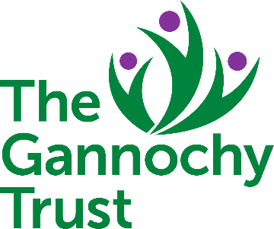
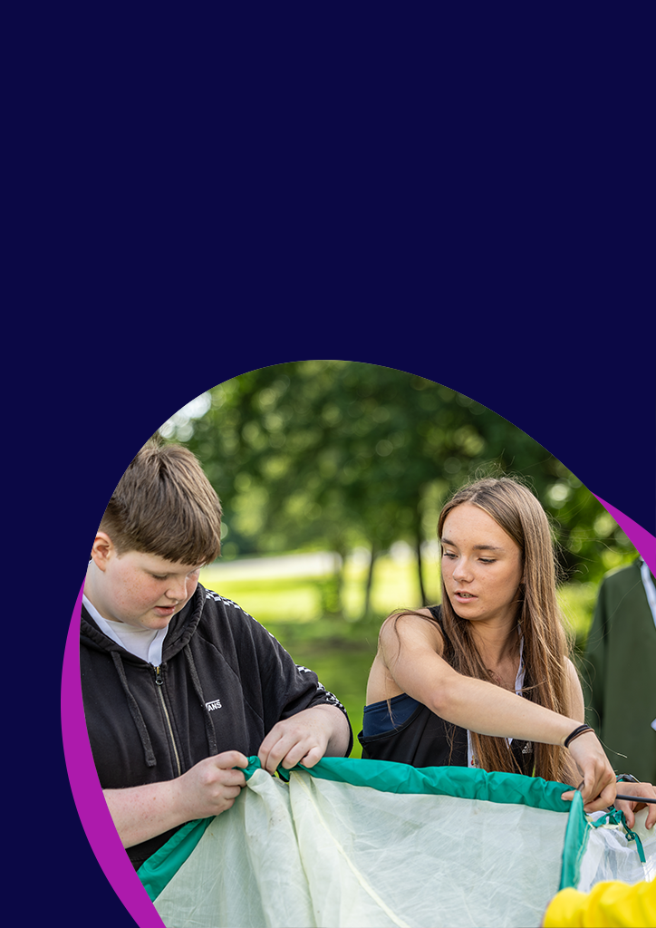


Youth Scotland Rural Action Fund

Application Form 2026

(Including Terms and Conditions)

Section 1 – Youth Group Details
Name of Youth Group:
*Youth Scotland Membership Number: | 350_ _ _ _ _
Contact Name:
Position in Youth Group:
Correspondence Address (incl. postcode):
If this is your personal address please place an X in this box:
Preferred contact number: | Evening Tel:
Alternative contact number: | Email:
Email:
Local Authority:
Youth Group’s website:
Postcode of the regular meeting place of your Youth Group:
Scottish Charity Number (if applicable): |  | SC
Do you currently receive funding from The Gannochy Trust? (if yes please contact us before applying) |  | Yes / No
Annual income:  (Please select one option which reflects your Youth Group’s most recent annual income e.g. 2020/21) | £0 - £9,999
 | £10,000 - £24,999
 | £25,000 - £49,999
 | £50,000 - £99,999
 | £100,000 - £200,000

*If you are not currently a member of Youth Scotland, you will need to become a member in order to access this funding. More information on joining can be found at https://www.youthscotland.org.uk/membership/join-and-renew/. Membership costs can be included in your application.

For office use only:
Reference  Number | Grant  Requested | Grant  Awarded | Eligibility  Checked | Project  Report due | Report received

Section 2 – Tell us what you want the funding for and why
Please tell us about your youth group. What services/activities do you offer to young people in your community?
Current number of volunteers and staff in your youth group:
Volunteers |  | Part-time staff |  | Full-time staff
Please describe the proposed activities and/or events for which you are applying for funding
Is this activity new? | Yes/No

Please tell us when the project will start and finish
Start date |  | End date
End date must be by end August 2026
 | How many young people will benefit from this funding?
 | Age Group | Male | Female | Other | Totals
 | 5 – 9
 | 10 – 17
 | 18 – 25
 | Totals
How have you identified the need for this project and how have you involved young people in developing your idea?

What difference will this funding make for young people in your community and your youth group?

How will you record what you have delivered and the difference that it makes?
(This may include capturing the opinions of young people during and following the project.)

Section 3 – Finances and Budgets
Expenditure | Estimated cost
e.g. Volunteer expenses
e.g. Venue hire
e.g. Activity equipment
Total cost
Grant requested
If your activity costs more than £750, please tell us how you are funding the balance and whether you have this funding confirmed.

Section 4 – additional information
Will youth awards be used to accredit this project? If so, which ones?
Did you know Youth Scotland member groups can register for free to use Hi5 Awards and Dynamic Youth Awards?

If you want to accredit your activity, please feel free to include the cost of challenge sheets in your budget. The Awards are also great way of evaluating your funded activity. Please email awards@youthscotland.org.uk for more information.

What are the barriers preventing young people from taking part in open access youth work in your community? (Please tick all that apply)

- Access to public transport to attend youth groups.
- Availability of youth workers and volunteers.
- Distance to activities and amenities.
- Lack of available venues locally.
- Access to equipment.
Other barriers not listed above:

What are the issues facing young people in your community?
What are the issues facing your youth group in the coming 6-12 months?

Section 5 – Statement to be signed by applicant
Declaration
To the best of my knowledge, the information provided on this application gives a true and accurate account of this youth group’s work. I confirm that I am authorised to commit my organisation in this way. I confirm that I am authorised to sign that we will follow and comply with the terms and conditions of this grant outlined below. I confirm that my organisation unconditionally authorises Youth Scotland to pass any details obtained about my organisation gathered in relation to this fund to our funders (see website for details) as supporters of this grants programme and relevant bodies involved in the decision-making process; to use such information as part of meeting Youth Scotland’s obligations to evaluate the impact of our work externally; and/or to use in promoting this programme through press or publications without the need to obtain any further consent or agreement from me or my youth group. Youth Scotland’s Privacy Policy details how we use, store and protect any personal data we manage through the provision of our programmes and membership services – please see https://www.youthscotland.org.uk/privacy-policy/
I confirm that this application will enable our youth group to provide youth work opportunities for young people in our local community and I have read and agree to the Terms and Conditions set out on pages 7-8.
Signature: |  | Date:

Have you previously received a grant from Youth Scotland? | YES |  | NO
If yes, have you returned your End of Project Report form? | YES |  | NO
Please note that if you have previously had a grant from Youth Scotland, we are unable to
assess your application until you have returned your report form

Answered all the questions on the application form? | YES
Application is signed in person by group leader? | YES
Included your latest annual income and expenditure accounts | YES
Included your most recent bank statement in the name of your youth group | YES

**If you are unsure about any part of this form please get in touch to talk it through**

Terms and Conditions

The grant is made on the basis of the following conditions set out below.

- The grant must only be used for the purposes outlined in the application form and must be spent by the project end date. There will be no increase in the amount awarded. If the total cost of the project is less than the grant awarded, the unspent amount must be returned to Youth Scotland promptly.

- There is no commitment to offer further financial support from the Youth Scotland Rural Action Fund for the specified project after the project activity has been completed.

- Funds will only be paid into a bank account in the name of the youth group which is submitting the application.

- Proper financial records of all Youth Scotland Rural Action Fund grant income and expenditure must be kept for a period of 12 months. If requested, copies of receipts or invoices must be made available, along with any other records, to Youth Scotland.

- You must adhere to accepted standards of practice, particularly in relation to safeguarding, child protection and use of online communication with young people. Please contact us if you are unsure about any aspect of this.

- All activities funded by the grant will comply with Youth Scotland’s policies on child protection and safety. All groups must be adequately covered for Public Liability Insurance cover. Please get in touch if you are unsure about your policies or insurance cover.

- The monitoring and evaluation of this funding is important to Youth Scotland and our supporters. The attached Guidance for applicant youth groups outlines what is required of your group relating to reporting on the difference this funding makes. Please read through this carefully.

By accepting this funding, the group agrees to certain monitoring requirements. The group must complete and submit an End of Project Report Form within three weeks of the end of your project. This is available on our website. We will be unable to provide funding to your group from this or any other fund delivered by Youth Scotland until we have received your End of Project Report.
- All projects should be identified as part of the Youth Scotland Rural Action Fund where appropriate (e.g. in Annual Report or other publicity) using the Youth Scotland logo.

- The grant agreement will be withdrawn and any grant made will fall to be repaid, in the event of any of the following occurring:

- Failure to comply with any terms and conditions contained in this letter, except where the prior written agreement of Youth Scotland has been obtained to the waiving of the term and conditions in question.

- The group ceases to function or is suspended or closed (or ceases to operate for the purposes outlined in their constitution).

- The group becomes apparently insolvent.

- Any information supported in connection with the grant application is found to be false or misleading, or it is found that relevant information has been withheld.

In order to receive the grant, please sign the application form agreeing to these terms and conditions and submit a copy of your most recent bank statement. You should return one completed application form to Youth Scotland and keep another copy for your files.

The grant will be paid by BACS transfer, as soon as possible once your application has been reviewed and approved for funding. Our aim is to review and confirm successful applications within six weeks of the application closing date.

Returning your application:

By email (preferable) to: office@youthscotland.org.uk

If unable to email, by post to: Balfour House, 19 Bonnington Grove, Edinburgh, EH6 4BL

This fund has been made possible through the generous support of our funder:

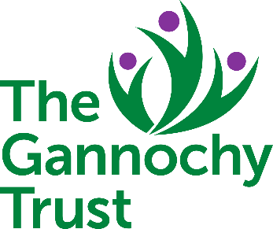
​​
​

Youth Scotland: Balfour House, 19 Bonnington Grove, Edinburgh EH6 4BL
​t: 0131 554 2561 ❙ e: office@youthscotland.org.uk www.youthscotland.org.uk
​A company limited by guarantee No: 125456. Scottish Charity No: SC000501. Registered in Scotland.​

