Professional Development Award in Youth Work

SCQF Level 6 – Youth Highland Course 2024
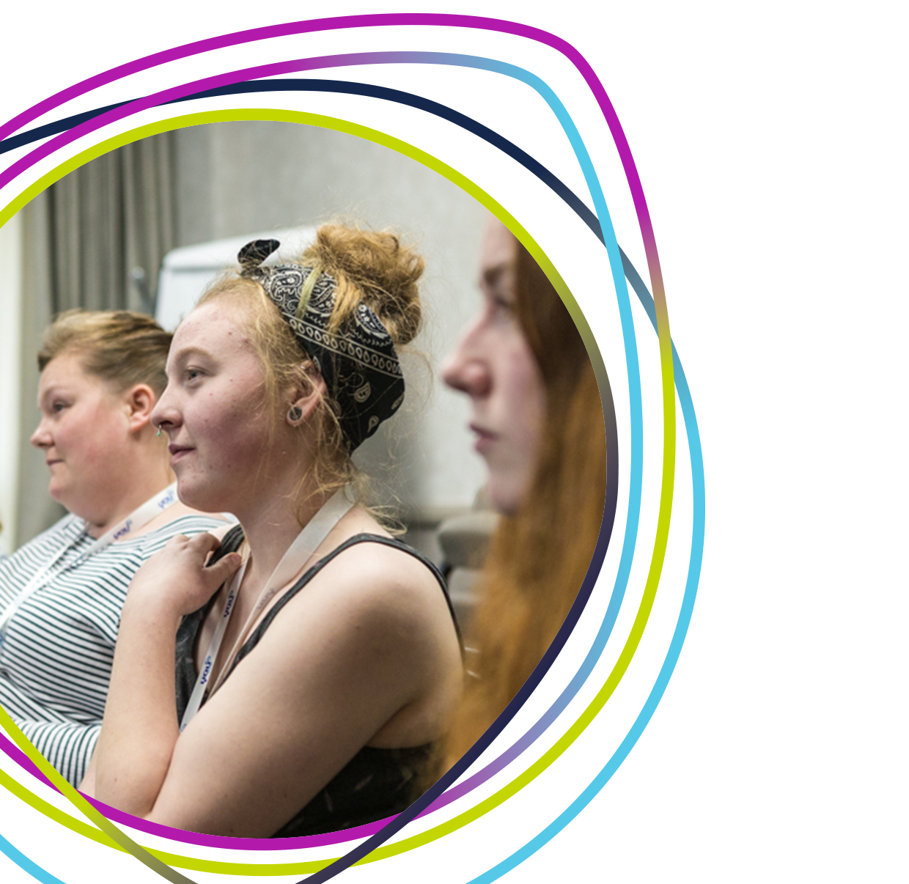

INFORMATION SHEET FOR PARTICIPANTS Youth Highland Course
Venue: Youth Highland (Office), The Pillar Box, High Street, Dingwall, IV15 9HA

INTRODUCTION
The PDA in Youth Work has been designed for those working with young people in a Youth Work context. It is suitable for people who have experience of youth work in a paid or volunteering capacity but who might not have formal qualifications in youth work.
The PDA in Youth Work offers a nationally recognised, SQA accredited qualification at SCQF Level 6.
Participants will be required to complete all three units and also to undertake a practical placement within their workplace or the youth club/group where they volunteer. As part of their practical placement, they will be expected to deliver youth work sessions and support young people to gain a Youth Scotland award. Training and funding for the young people’s awards will be provided. In order to complete the PDA, participants will be observed delivering youth work in their workplace or the group/club where they volunteer.

ENTRY REQUIREMENTS
All applicants/participants must be 18 + * and be able to demonstrate that they:
- Have 1 year experience of regularly working/volunteering in a youth work setting.
- Have completed the Youth Scotland Ready for Youth Work 2-day course (in person or online 6 sessions) or equivalent covering core competencies as per the National Youth Work Induction Checklist.
- Have completed a Child Protection Awareness course in the past 2 years.
- Currently work or volunteer in a youth work setting.
- Have written permission from their workplace or the youth group where they volunteer, confirming they can be observed delivering youth work as part of the PDA course.
- Are able to attend all the outlined training sessions and undertake all the required assessments.
*Young leaders aged 16+ – 18 who you are suitably experienced may also be considered

COURSE STRUCTURE
This course will be delivered by Youth Scotland using course materials developed by Youth Scotland and LAYC.
The course will involve six main delivery sessions designed to build knowledge and skills in working with young people. Participants are required to take part in all six organised sessions of the programme. Participants will also be required to undertake additional research and learning activities in their own time and to compile a learning log / portfolio to evidence their work.
The PDA in Youth Work is divided into three units of work.
- Understanding and Exploring Youth Work
- Engaging Young People
- Delivering Youth Work

Unit 1 will be delivered (or taught) first to introduce participants to the underpinning knowledge they need to undertake Units 2 and Unit 3. Throughout Units 2 and 3, participants must practice developing their youth work skills within their own workplace/ volunteer setting. Unit 3 requires each participant to plan, organise and lead youth work sessions in their own workplace/ volunteer setting.

UNITS AND LEARNING OUTCOMES
On completion of each unit, participants must demonstrate competence, knowledge and skills in each of the Learning Outcomes.

UNIT 1 Understanding and Exploring Youth Work
The Unit introduces participants to the context, core values and principles which underpin youth work and raises awareness of the issues facing young people and those working with them. It provides underpinning knowledge and understanding for the National Occupational Standards for Youth Work.
On completion of the Unit the participants should be able to:
- Explain the current context of youth work in Scotland
- Outline current definitions of youth work in Scotland
- Explain the core values and principles underpinning youth work
- Outline the factors which may impact on youth work practice

UNIT 2 Engaging Young People
This Unit is designed to provide participants with an understanding of communication and group work skills necessary to engage with young people in a range of settings.
On completion of the Unit the participants should be able to:
- Describe a range of approaches which may be used to engage with young people
- Outline relevant communication and interpersonal skills required of the youth worker
- Describe group work skills used in youth work.

UNIT 3 Delivering Youth Work
This Unit is designed to provide participants with the knowledge and skills required to work with young people in a range of youth work settings. It offers opportunities to develop practical skills and to demonstrate the application of the core values and principles of youth work in practice.
On completion of the Unit the participants should be able to:
- Demonstrate the application of core values and principles of youth work in practice
- Engage with young people in a youth work setting
- Plan, deliver and review a youth work activity

THE LEARNING LOG/PORTFOLIO
Participants will be required to keep a learning log /portfolio to record and evidence their learning throughout the course. Support on how to complete this log / portfolio will be given. 10 sessions are to be logged.

ASSESSMENTS
Participants will be asked to undertake assessments for each unit. This will form part of their portfolio, see above.
As part of the assessment of Unit 3, participants will also be observed delivering a youth work activity in their own workplace/ volunteer setting. This observation will be carried out by a suitable person – either one of the course tutors or by a suitable workplace supervisor / colleague with prior agreement with Youth Scotland.

CERTIFICATION
Once participants have satisfactorily completed all three units of the PDA, the Approved Centre (Youth Scotland) will process the paperwork and SQA will issue the PDA Certificate.

Course Timetable
Unit 1 |  | Day 1 | Saturday 31st August 24 | 10am – 4.30pm (in person)
 |  | Day 2 | Sunday 1st September 24 | 10am – 4.30pm (in person)
Unit 2 |  | Day 1 | Saturday 28th September 24 | 10am – 4.30pm (in person)
 |  | Day 2 | Sunday 29th September 24 | 10am – 4.30pm (in person)
Unit 3 |  | Day 1 | Saturday 2nd November 24 | 10am – 4.30pm (in person)
 |  | Day 2 | Saturday 30th November 24 | 10am – 4.30pm (in person)

*Observed Practice session to take place during Unit 3, between 2nd and 30th November. The Candidate is responsible to agree dates with organisation, young people and assigned Assessor.

Assessment Due Dates (assessments are to be submitted no later than):
- Unit 1: Thursday 19th September 2024 12noon
- Unit 2: Thursday 17th October 2024 12noon
- Unit 3: Thursday 19th December 12noon

A detailed programme for each of the sessions will be given to candidates at the start of each unit.

SUPPORT
All candidates will be supported throughout the course by members of the training team but will also need support from within their workplace/place where they volunteer.

SQA REGISTRATION
This is a community based course, delivered by Youth Scotland and accredited by SQA.
Youth Scotland is an SQA Approved Centre and all candidates will be required to register with the Scottish Qualification Authority (SQA).

Investment: £100 (Members)
This course is generously subsidised by Funding secured by Youth Scotland to benefit our member groups. The true market value of this invaluable program exceeds £500 per participant. For further details or to discuss this opportunity, please reach out to Julie.middlemissbrown@youthscotland

Please complete the PDA Youth Highland 2024 course application form by clicking on this link;
PDA Applications link
- Application forms must be completed and signed by the applicant.
- Application forms must be returned by no later than Thursday 27th June 2024 5pm.
- Successful applicants will be advised by Tuesday 2nd July. A formal acceptance form will be sent out to those offered places which must be completed and returned asap.
- The first session of the course will take place in person on Saturday 31st August 10am-4.30pm

PLEASE NOTE THAT YOU MUST BE ABLE TO ATTEND ALL THE LISTED SESSIONS.

For further information about the PDA in Youth Work course contact:

Julie Middlemiss Brown
Senior Development Worker (Youth Work and Training)
Youth Scotland
Tel: 07788298521
Julie.middlemissbrown@youthscotland.org.uk

